# LAB 05

# Python if and else Statements

1. **Basic Task:** Write a program that checks if a given number is positive, negative, or zero.

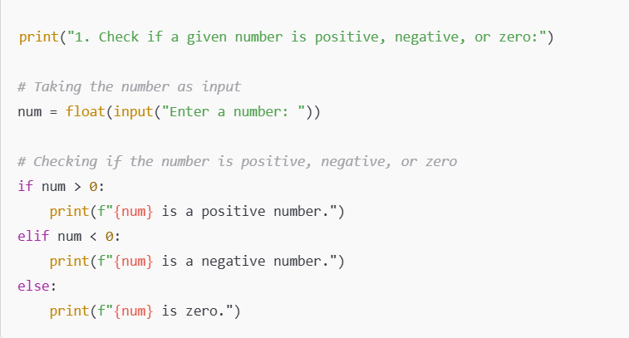

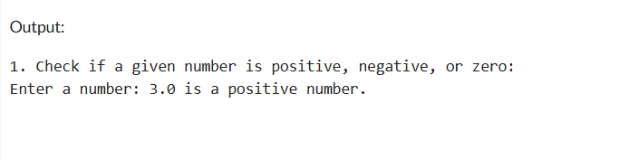

1. **Intermediate Task:** Write a program that takes user input and determines whether it's a even or odd.

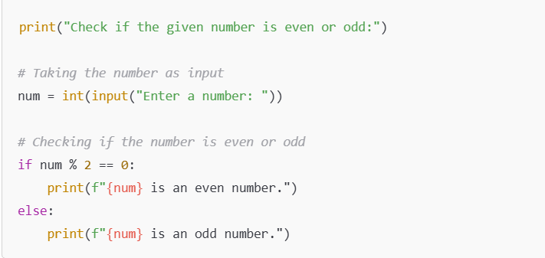

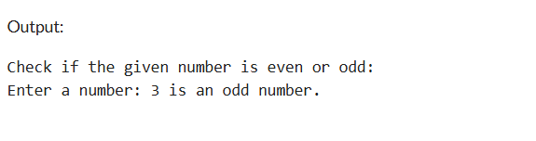

1. **Advanced Task:** Create a program that asks user to print:
   * "Excellent" if marks are above 80
   * "Good" if marks are between 60 and 80
   * "Needs Improvement" if marks are below 60

